

Wander Inn
Project Report
Developed By:
Muhammad Rafay 22i-0948
Arham Khalid 22i-1156
Maaz Khan

Table of Contents

A. Software Project Plan (PDF) [15 Marks]
1.1 Work Breakdown Structure of Your System
1.2 Project Gantt Chart

B. System Architecture [15 Marks]
2.1 Identifying Subsystems
2.2 UML Package Diagram of Subsystems
2.3 Architecture Styles
2.4 Deployment Diagram for Client Deployments
2.5 Component Diagrams

C. Test Cases – Black Box Testing [20 Marks]
3.1 Equivalence Class Partitioning
3.2 Boundary Value Analysis
3.3 Validation of System Functionality

D. White Box Testing [20 Marks]
4.1 Unit Testing Using Suitable Tools
4.2 Generate Coverage Report
4.3 Coverage Report Submission
4.4 Coverage Explanation Note

E. Final Report [20 Marks]
5.1 Project Report (Both Hard and Soft Form)
5.2 Final Report Content

Project Introduction

Functional and Non-Functional Requirements

User Stories

Product Backlog

Sprint 1 and Sprint 2 Backlog

Project Plan

Architecture Diagram

Design (Sprint 3 Items)

Actual Implementation Screenshots

Product Burn Down Chart

Trello Board Screenshots

Test Cases – Black Box

Test Cases – White Box

Work Division

Lessons Learned

G. PowerPoint Presentation [10 Marks]
6.1 Project Introduction
6.2 Functional Requirements
6.3 Non-Functional Requirements (2 NFRs)
6.4 Design – Class Diagram
6.5 Architecture Diagram
6.6 Actual Implementation Screenshots
6.7 Work Division Between Group Members
6.8 Lessons Learned

1. Problem Statement

The problem of | Finding temporary accommodation can be a daunting task due to high service fees, lack of transparency, and limited availability of well-reviewed listings. Many travelers struggle to secure accommodations that match their preferences, budget, and specific needs, leading to dissatisfaction and inefficient booking experiences.
affects | Both travelers seeking flexible, personalized, and affordable short-term rentals, as well as property owners who want to effectively manage listings, optimize pricing, and maintain high occupancy rates.
the impact of which is | Inefficient booking processes, frustration among travelers, potential revenue loss for property owners, and an overall lack of trust in the short-term rental market. This can result in missed opportunities for hosts and a suboptimal experience for guests.
a successful solution would be | A robust, feature-rich, and user-centric rental platform that integrates dynamic search filters, secure payment processing, verified reviews, real-time availability updates, streamlined communication between hosts and guests, and an intelligent pricing model. This solution aims to improve efficiency, convenience, and reliability for both travelers and property owners.

Background:
Finding temporary accommodation can be a daunting task due to high service fees, lack of transparency, and limited availability of well-reviewed listings. Many travelers find it difficult to secure accommodations that match their preferences, budget, and specific needs, leading to dissatisfaction and inefficient booking experiences. Traditional hotel booking systems often fail to offer the personalized experience, flexibility, and affordability that travelers seek, while informal rental options lack credibility and security.
Additionally, hosts face significant challenges in managing their rental properties. Many property owners struggle with optimizing pricing strategies, maintaining high occupancy rates, and ensuring effective communication with guests. Furthermore, without an integrated and user-friendly platform, hosts must rely on disjointed third-party services for listing, payment processing, and customer interactions, leading to inefficiencies and potential revenue loss.
A robust and feature-rich accommodation platform is necessary to bridge these gaps by providing a transparent, efficient, and user-friendly experience for both travelers and property owners.
Finding temporary accommodation can be challenging due to high service fees, lack of transparency, and limited availability of well-reviewed listings. Traditional hotel booking systems may not offer the personalized experience or flexibility that travelers seek, while hosts often struggle with managing multiple listings and optimizing pricing.

2.Problem Description:
This project aims to develop WanderInn– Home Rental & Booking System, providing a seamless and intuitive platform where property owners can list their rentals and travelers can effortlessly find and book accommodations. By integrating essential features such as dynamic search filters, secure payment processing, verified reviews, and real-time availability updates, the system seeks to enhance the overall user experience for both guests and hosts.
The platform will address common pain points such as unreliable guest and host reviews, inefficient booking processes, and inadequate pricing models. It will incorporate an intelligent pricing system that allows hosts to optimize their rates based on demand and market trends. Furthermore, a robust communication and notification system will facilitate seamless interactions between hosts and guests, reducing booking-related uncertainties.The system will also address common challenges faced by both guests and hosts, such as unreliable reviews, inefficient communication, and the absence of an intelligent pricing model. By implementing a robust search and booking mechanism, secure payments, and an intuitive dashboard for hosts, our solution seeks to improve the overall short-term rental experience.
To enhance trust and security, the system will implement identity verification, fraud prevention mechanisms, and a structured dispute resolution process. Additionally, it will provide an interactive dashboard for hosts to manage listings, track earnings, and analyze booking performance.
By offering a feature-rich and user-centric rental booking system, this solution aims to significantly improve the efficiency, convenience, and reliability of short-term rentals, catering to the evolving needs of both travelers and property owners.

3.Roles & Responsibilities
- Product Owner→(Maaz Khan): Responsible for defining the product vision, prioritizing backlog items, and maintaining clear communication with stakeholders. Ensures that the team understands the project goals and user needs while aligning development with business objectives. Monitors progress and adapts priorities based on evolving requirements.
- Scrum Master→(Arham Khalid): Oversees the Agile development process, facilitates sprint planning, daily stand-ups, sprint reviews, and retrospectives. Works to remove impediments that hinder team progress, fosters a collaborative work environment, and ensures adherence to Agile best practices.
- Scrum Team→(Muhammad Rafay): Comprises developers, designers, and testers responsible for designing, developing, testing, and deploying project features. Ensures high-quality deliverables through continuous integration, peer code reviews, and feedback-driven improvements. Actively participates in sprint planning, backlog refinement, and retrospectives to optimize workflow and efficiency.

4. Functional Requirements

4.1.1 User Management
- The system shall allow users to register, log in, and manage their profiles.
- The system shall support role-based access control (Guest, Host, Admin).

4.1.2 Booking System
- Guests shall be able to check availability and make bookings.
- The system shall allow hosts to approve or reject booking requests.
- Users shall receive real-time booking notifications.

4.1.3 Payment System
- The system shall manage payments.
- The system shall generate invoices and send confirmation emails.

4.2 Non-Functional Requirements

4.2.1 Product Requirements
- The system shall have a minimal response time(1-2 secs) .
- The system shall be accessible on mobile and desktop devices.
- The system shall support a high concurrent user load(1000 users),

4.2.2 Organizational Requirements
- The system shall follow Agile development practices.
- The system shall use GitHub for version control.
- The system shall use Trello for task management, tracking development progress, sprints, and issue resolution.

5.User Stories

User Story 1:
- As a user, I want to sign up with my email so that I can create an account.
- Acceptance Criteria:
  - Given a new user, when they provide a valid email and password, then their account should be created successfully.
  - Given an existing user, when they try to sign up with the same email, then they should receive an error message.

User Story 2:
- As a user, I want to log in securely so that I can access my profile.
- Acceptance Criteria:
  - Given a registered user, when they enter valid credentials, then they should be logged in successfully.
  - Given an unregistered user, when they attempt to log in, then they should receive an error message.

Property Listings

User Story 3:
- As a host, I want to add a new property listing so that guests can book it.
- Acceptance Criteria:
  - Given a host, when they provide all required details, then the property should be added successfully.
  - Given a host, when they miss mandatory fields, then they should receive an error message.

User Story 4:
- As a host, I want to upload multiple images of my property so that guests can see the details.
- Acceptance Criteria:
  - Given a host, when they upload images, then the images should be displayed in the listing.
  - Given a host, when they upload more than 10 images, then the system should show an error message.

Booking System

User Story 5:
- As a guest, I want to receive an email confirmation after booking so that I have proof of my reservation.
- Acceptance Criteria:
  - Given a guest, when they complete a booking, then they should receive an email confirmation.
  - Given a guest, when they do not receive an email, then they should have an option to request a resend.

User Story 6:
- As a guest, I want to filter properties based on amenities so that I can find a property that meets my needs.
- Acceptance Criteria:
  - Given a guest, when they select specific amenities, then only matching properties should be displayed.
  - Given a guest, when no properties match the selected amenities, then they should see a 'No Listings Found' message.

User Story 7:
- As a host, I want to set cancellation policies so that I can manage my bookings effectively.
- Acceptance Criteria:
  - Given a host, when they select a cancellation policy, then it should be displayed on the property listing.
  - Given a guest, when they book a property, then they should be informed of the cancellation policy before confirming.

User Story 8:
- As a guest, I want to see trending destinations on the homepage so that I can discover new places to visit.
- Acceptance Criteria:
  - Given a guest, when they visit the homepage, then they should see a section for trending destinations.
  - Given a guest, when they click on a trending destination, then they should be redirected to listings in that area.

User Story 9:
- As a host, I want to receive notifications when a guest books my property so that I can prepare for their stay.

Acceptance Criteria:
  - Given a host, when a guest books their property, then they should receive a notification.
  - Given a host, when they mark the notification as read, then it should be removed from their notifications list.

User Story 10:
- As an admin, I want to moderate property listings so that I can ensure quality standards.
- Acceptance Criteria:
  - Given an admin, when they review a property listing, then they can approve or reject it.
  - Given a host, when their listing is rejected, then they should receive a notification with the reason.

User Story 11:
- As a guest, I want to view my past bookings so that I can easily rebook properties.
- Acceptance Criteria:
  - Given a guest, when they navigate to their booking history, then they should see a list of past reservations.
  - Given a guest, when they click on a past booking, then they should have the option to rebook the property.

User Story 12:
- As a host, I want to track my earnings through a financial dashboard so that I can manage my income.
- Acceptance Criteria:
  - Given a host, when they visit their dashboard, then they should see a breakdown of their earnings.
  - Given a host, when they apply filters, then the financial data should update accordingly.

User Story 13:
- As a guest, I want to contact customer support if I encounter an issue so that I can resolve problems quickly.
- Acceptance Criteria:
  - Given a guest, when they navigate to the support section, then they should see options to contact support.
  - Given a guest, when they submit a support ticket, then they should receive a reference number.

User Story 14:
- As an admin, I want to track platform performance analytics so that I can improve the service.
- Acceptance Criteria:
  - Given an admin, when they log in, then they should have access to analytics data.
  - Given an admin, when they apply filters, then the analytics dashboard should update accordingly.

User Story 15:
- As a guest, I want to leave a review after my stay so that I can share my experience.
- Acceptance Criteria:
  - Given a guest, when they have completed a stay, then they should be able to submit a review.
  - Given a guest, when they submit a review, then it should be visible on the property listing.

5. Product Backlog

User Authentication & Profiles

User Story 1:
- As a user, I want to sign up with my email so that I can create an account.
- Acceptance Criteria:
  - Given a new user, when they provide a valid email and password, then their account should be created successfully.
  - Given an existing user, when they try to sign up with the same email, then they should receive an error message.

User Story 2:
- As a user, I want to log in securely so that I can access my profile.
- Acceptance Criteria:
  - Given a registered user, when they enter valid credentials, then they should be logged in successfully.
  - Given an unregistered user, when they attempt to log in, then they should receive an error message.

Property Listings

User Story 3:
- As a host, I want to add a new property listing so that guests can book it.
- Acceptance Criteria:
  - Given a host, when they provide all required details, then the property should be added successfully.
  - Given a host, when they miss mandatory fields, then they should receive an error message.

User Story 4:
- As a host, I want to upload multiple images of my property so that guests can see the details.
- Acceptance Criteria:
  - Given a host, when they upload images, then the images should be displayed in the listing.
  - Given a host, when they upload more than 10 images, then the system should show an error message.

Booking System

User Story 5:
- As a guest, I want to receive an email confirmation after booking so that I have proof of my reservation.
- Acceptance Criteria:
  - Given a guest, when they complete a booking, then they should receive an email confirmation.
  - Given a guest, when they do not receive an email, then they should have an option to request a resend.

User Story 6:
- As a guest, I want to filter properties based on amenities so that I can find a property that meets my needs.
- Acceptance Criteria:
  - Given a guest, when they select specific amenities, then only matching properties should be displayed.
  - Given a guest, when no properties match the selected amenities, then they should see a 'No Listings Found' message.

User Story 7:
- As a host, I want to set cancellation policies so that I can manage my bookings effectively.
- Acceptance Criteria:
  - Given a host, when they select a cancellation policy, then it should be displayed on the property listing.
  - Given a guest, when they book a property, then they should be informed of the cancellation policy before confirming.

User Story 8:
- As a guest, I want to see trending destinations on the homepage so that I can discover new places to visit.
- Acceptance Criteria:
  - Given a guest, when they visit the homepage, then they should see a section for trending destinations.
  - Given a guest, when they click on a trending destination, then they should be redirected to listings in that area.

User Story 9:
- As a host, I want to receive notifications when a guest books my property so that I can prepare for their stay.

Acceptance Criteria:
  - Given a host, when a guest books their property, then they should receive a notification.
  - Given a host, when they mark the notification as read, then it should be removed from their notifications list.

User Story 10:
- As an admin, I want to moderate property listings so that I can ensure quality standards.
- Acceptance Criteria:
  - Given an admin, when they review a property listing, then they can approve or reject it.
  - Given a host, when their listing is rejected, then they should receive a notification with the reason.

User Story 11:
- As a guest, I want to view my past bookings so that I can easily rebook properties.
- Acceptance Criteria:
  - Given a guest, when they navigate to their booking history, then they should see a list of past reservations.
  - Given a guest, when they click on a past booking, then they should have the option to rebook the property.

User Story 12:
- As a host, I want to track my earnings through a financial dashboard so that I can manage my income.
- Acceptance Criteria:
  - Given a host, when they visit their dashboard, then they should see a breakdown of their earnings.
  - Given a host, when they apply filters, then the financial data should update accordingly.

User Story 13:
- As a guest, I want to contact customer support if I encounter an issue so that I can resolve problems quickly.
- Acceptance Criteria:
  - Given a guest, when they navigate to the support section, then they should see options to contact support.
  - Given a guest, when they submit a support ticket, then they should receive a reference number.

User Story 14:
- As an admin, I want to track platform performance analytics so that I can improve the service.
- Acceptance Criteria:
  - Given an admin, when they log in, then they should have access to analytics data.
  - Given an admin, when they apply filters, then the analytics dashboard should update accordingly.

User Story 15:
- As a guest, I want to leave a review after my stay so that I can share my experience.
- Acceptance Criteria:
  - Given a guest, when they have completed a stay, then they should be able to submit a review.
  - Given a guest, when they submit a review, then it should be visible on the property listing.

5.2 Sprint Backlog (User Stories for Next Iteration)

Iteration 1
- User Sign-Up: Users will be able to create an account using their email and password.
- User Login: Registered users will be able to log in securely to access their profiles.
- Property Listing Creation: Hosts can add new property listings, ensuring guests have access to available options.
- Property Image Upload: Hosts can upload multiple images to showcase their properties effectively.
- Booking Email Confirmation: Guests will receive an email confirmation upon booking a property, ensuring they have a record of their reservation.

Iteration 2
- Advanced Filtering System: Guests can filter properties based on amenities such as Wi-Fi, parking, pet-friendliness, and more to refine their search.
- Host Cancellation Policy Management: Hosts will be able to set, modify, and enforce their own cancellation policies to provide clarity for guests.
- Trending Destinations Feature: A dynamic section will be added to the homepage, displaying popular destinations to inspire guest bookings.
- Host Booking Notifications: Hosts will receive instant notifications when a booking is made for their property, ensuring timely updates.
- Admin Property Moderation: Admins will have the ability to review, approve, or reject property listings before they go live to maintain platform quality.

A. Software Project Plan

1. Work Breakdown Structure of Your System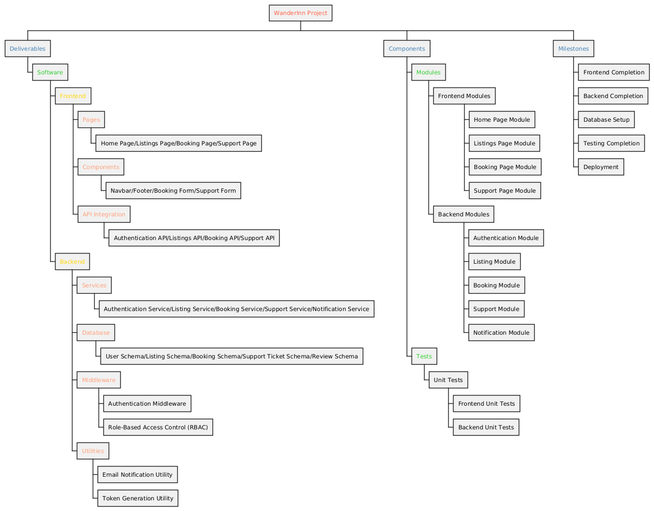

2. Project Gantt Chart
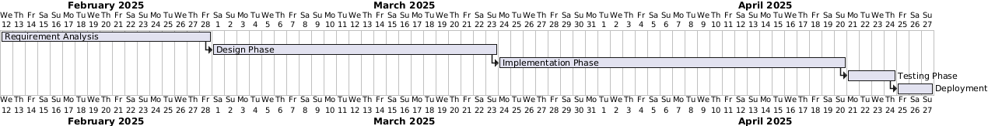

B. System Architecture
Identifying Subsystems
The WanderInn project is a comprehensive system designed to facilitate property rentals, bookings, and user interactions. The system is divided into several subsystems, each responsible for a specific set of functionalities. These subsystems are designed to work together seamlessly, ensuring a smooth user experience. Below is a detailed breakdown of the subsystems, including both the frontend and backend components.

1. Frontend Subsystem
The frontend subsystem is built using Next.js, a React-based framework for building user interfaces. It is responsible for presenting the application to users and handling client-side interactions.

Key Components:

- UI Pages:
- Home Page: Displays trending destinations, featured properties, and navigation options.
- Listings Page: Allows users to browse and filter property listings.
- Booking Page: Enables users to book properties and view booking details.
- Support Page: Provides a form for users to submit support tickets.

- UI Components:
- Navbar: Provides navigation across the application.
- Footer: Displays additional links and contact information.
- Booking Form: Collects user input for property bookings.
- Support Form: Collects user input for submitting support tickets.

- API Client:
- Handles communication with the backend via REST APIs.
- Includes modules for:
  - Authentication: Login, registration, and token management.
  - Listings: Fetching and filtering property listings.
  - Bookings: Creating and managing bookings.
  - Support: Submitting and viewing support tickets.

Responsibilities:
- Render dynamic content based on user interactions.
- Communicate with the backend to fetch or submit data.
- Ensure responsiveness and accessibility across devices.

2. Backend Subsystem
The backend subsystem is built using Node.js and Express.js. It provides the core functionality of the system, including data processing, business logic, and database interactions.

Key Components:
- Authentication Service:
- Handles user registration, login, and role-based access control (e.g., user, host, admin).
- Uses JWT (JSON Web Tokens) for secure authentication.

2.Listing Service:

- Manages property listings, including creation, updates, and approvals.
- Provides filtering and search functionality for listings.

3. Booking Service:
- Handles property bookings, including creating, updating, and deleting bookings.
- Sends notifications to hosts when a booking is made.

4.Support Service:
- Manages support tickets submitted by users.
- Allows admins to view and update ticket statuses.

5. Notification Service:
- Sends email notifications to hosts and users using Nodemailer.
- Stores notifications in the database for hosts to view.

6.Database Management:
- Uses MongoDB Atlas for storing and managing data.
- Includes schemas for:
  - User: Stores user details, roles, and notifications.
  - Listing: Stores property details, amenities, and availability.
  - Booking: Stores booking details, payment status, and special requests.
  - SupportTicket: Stores support ticket details and statuses.
  - Review: Stores user reviews for properties.
7.Middleware:

- Authentication Middleware: Verifies JWT tokens and ensures secure access to protected routes.
- Role-Based Access Control (RBAC): Restricts access to certain routes based on user roles (e.g., admin-only routes).
8.Utilities:

- Email Utility: Sends email notifications using Nodemailer.
- Token Utility: Generates JWT tokens for authentication.
- Responsibilities:
  - Process client requests and return appropriate responses.
  - Enforce business logic and security policies.
  - Interact with the database to store and retrieve data.

9. Database Subsystem:
The database subsystem is hosted on MongoDB Atlas, a cloud-based NoSQL database service. It stores all the data required for the system's operation.

Key Collections:
- Users:
  - Stores user details, roles (user, host, admin), and notifications.
  - Includes hashed passwords for secure authentication.
- Listings:
  - Stores property details, including title, description, location, price, and amenities.
  - Tracks the status of listings (e.g., pending, approved, rejected).
- Bookings:
  - Stores booking details, including property, user, check-in/check-out dates, and payment status.
- SupportTickets:
  - Stores support tickets submitted by users, including issue descriptions and statuses.
- Reviews:
  - Stores user reviews for properties, including ratings and comments.
- Responsibilities:
  - Provide a persistent storage layer for the system.
  - Ensure data integrity and consistency.
  - Support efficient querying and indexing for fast data retrieval.
10. Integration Subsystem:
The integration subsystem ensures seamless communication between the frontend and backend.

Key Features:
- REST APIs:
  - Expose endpoints for frontend interaction with the backend.
  - Include routes for authentication, listings, bookings, support tickets, and notifications.
- API Security:
  - Use JWT tokens for secure communication.
  - Implement role-based access control to restrict sensitive operations.
- Error Handling:
  - Return appropriate error messages for invalid requests.
  - Log errors for debugging and monitoring.
- Responsibilities:
  - Act as the bridge between the frontend and backend.
  - Ensure secure and efficient data exchange.
  - Subsystem Interactions
- Frontend to Backend:
  - The frontend sends HTTP requests to the backend via REST APIs.
  - Example: A user submits a booking form, and the frontend sends the data to the backend's booking service.
- Backend to Database:
  - The backend interacts with MongoDB Atlas to store and retrieve data.
  - Example: The booking service saves a new booking in the Bookings collection.
- Backend to External Services:
  - The backend uses Nodemailer to send email notifications.
  - Example: When a booking is created, the backend sends an email to the host.

Summary

The WanderInn system is divided into the following subsystems:

- Frontend Subsystem:
  - Handles user interactions and communicates with the backend.
- Backend Subsystem:
  - Processes requests, enforces business logic, and interacts with the database.
- Database Subsystem:
  - Provides persistent storage for users, listings, bookings, support tickets, and reviews.
- Integration Subsystem:
  - Facilitates secure and efficient communication between the frontend and backend.
This modular design ensures scalability, maintainability, and a seamless user experience.

2. UML Package Diagram of Subsystems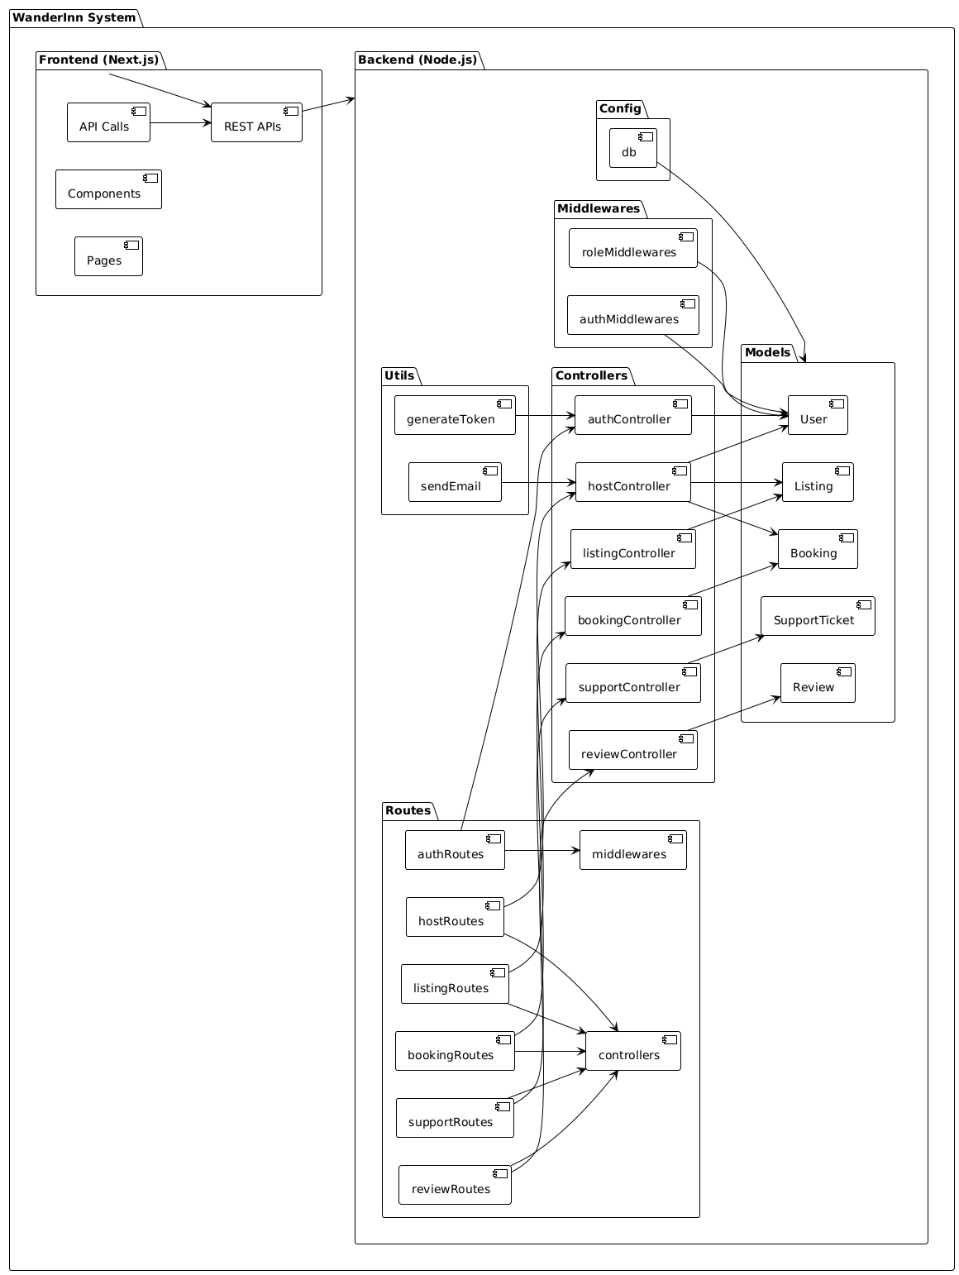

Explanation of the Diagram

Subsystems:

Routes: Handles API endpoints for different functionalities (e.g., authentication, listings, bookings, reviews, support, and host-specific actions).

Controllers: Contains business logic for handling requests and interacting with models.

Models: Represents the database schemas for User, Listing, Booking, Review, and SupportTicket.

Middlewares: Handles authentication (authMiddlewares) and role-based access control (roleMiddlewares).

Utils: Contains utility functions like sendEmail for email notifications and generateToken for JWT generation.

Config: Handles database connection setup.

Relationships:

Routes depend on controllers to handle requests.

Controllers interact with models to perform CRUD operations.

Middlewares ensure secure access to routes.

Utility functions are used by controllers for specific tasks (e.g., sending emails, generating tokens)

3. Architecture Styles

The architecture style used in this project can be described as a combination of Client-Server and MVC (Model-View-Controller). Here's a breakdown of the architecture styles:
Client-Server Architecture
Description:
- The project follows a client-server architecture, where the frontend (Next.js) acts as the client and the backend (Node.js/Express) acts as the server.
- The client communicates with the server via REST APIs to perform operations like user authentication, booking properties, submitting reviews, and more.

Key Characteristics:
- Separation of Concerns: The frontend and backend are decoupled, allowing independent development and deployment.
- Communication: The client sends HTTP requests to the backend, and the backend responds with JSON data.
- Components:
  - Frontend: Built with Next.js, it handles the user interface and makes API calls to the backend.
  - Backend: Built with Node.js/Express, it processes requests, interacts with the database, and returns responses.
MVC (Model-View-Controller) Architecture
Description:
- The backend follows the MVC architecture, which separates the application logic into three main components:
- Model: Represents the data and business logic (e.g., User, Listing, Booking, SupportTicket models).
- View: Not directly applicable in the backend, as the frontend handles the presentation layer.
- Controller: Handles the application logic and processes incoming requests (e.g., authController, listingController, bookingController).
Key Characteristics:
- Separation of Concerns: Each layer has a distinct responsibility, making the codebase easier to maintain and scale.
- Reusability: Models and controllers can be reused across different routes and features.
- Components:
  - Models: Define the database schemas using Mongoose (e.g., User, Listing, Booking, SupportTicket).
  - Controllers: Contain the business logic for handling requests and interacting with models (e.g., authController, supportController).
  - Routes: Define the API endpoints and map them to the appropriate controllers (e.g., authRoutes, listingRoutes, supportRoutes).

4. Deployment Diagram for Client Deployments

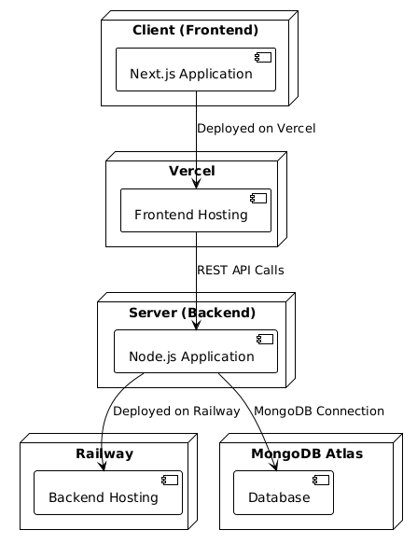

5. Component Diagrams

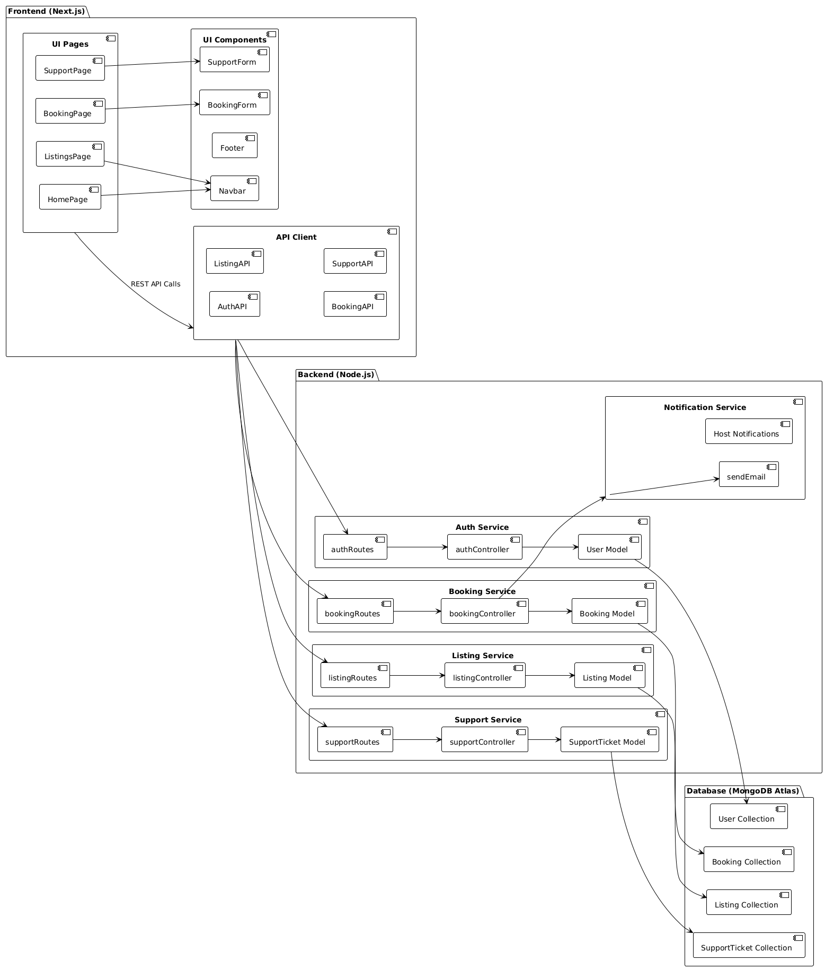

C. Test Cases – Black Box Testing

1. Equivalence Class Partitioning
1. User Registration
- Inputs:
  - name: String
  - email: String (must be a valid email format)
  - password: String (must meet security requirements)
Equivalence Classes:
Input Field | Valid Partition | Invalid Partitions
name | Non-empty string | Empty string, excessively long string
email | Valid email format (e.g., user@domain.com) | Invalid email format (e.g., user@domain, userdomain.com, empty string)
password | String with at least 8 characters | Less than 8 characters, empty string, excessively long string
2. User Login
- Inputs:
  - email: String
  - password: String
  - Equivalence Classes:
Input Field | Valid Partition | Invalid Partitions
email | Registered email in the database | Unregistered email, invalid email format, empty string
password | Correct password for the registered email | Incorrect password, empty string
3. Create a Listing
- Inputs:
  - title: String
  - description: String
  - location: String
  - price: Number
  - bedrooms: Number
  - bathrooms: Number
  - maxGuests: Number
  - cancellationPolicy: String (e.g., "Flexible", "Moderate", "Strict")
Equivalence Classes:
Input Field | Valid Partition | Invalid Partitions
title | Non-empty string | Empty string, excessively long string
description | Non-empty string | Empty string, excessively long string
location | Non-empty string | Empty string
price | Positive number | Negative number, zero, non-numeric values
bedrooms | Positive integer | Negative number, zero, non-integer values
bathrooms | Positive integer | Negative number, zero, non-integer values
maxGuests | Positive integer | Negative number, zero, non-integer values
cancellationPolicy | "Flexible", "Moderate", "Strict" | Empty string, invalid values (e.g., "None", "Custom")
4. Create a Booking
- Inputs:
  - property: Object ID (must exist in the database)
  - checkIn: Date
  - checkOut: Date
  - guests: Number
  - totalPrice: Number
  - paymentMethod: String (e.g., "Credit Card", "PayPal", "Bank Transfer", "Cash")
Equivalence Classes:
Input Field | Valid Partition | Invalid Partitions
property | Valid Object ID in the database | Invalid Object ID, non-existent property ID, empty string
checkIn | Future date | Past date, invalid date format, empty string
checkOut | Future date after checkIn | Past date, date before checkIn, invalid date format, empty string
guests | Positive integer | Negative number, zero, non-integer values
totalPrice | Positive number | Negative number, zero, non-numeric values
paymentMethod | "Credit Card", "PayPal", "Bank Transfer", "Cash" | Empty string, invalid values (e.g., "Bitcoin", "Check")

5. Submit a Review
- Inputs:
  - propertyId: Object ID (must exist in the database)
  - rating: Number (1 to 5)
  - comment: String
Equivalence Classes:
Input Field | Valid Partition | Invalid Partitions
propertyId | Valid Object ID in the database | Invalid Object ID, non-existent property ID, empty string
rating | Integer between 1 and 5 | Less than 1, greater than 5, non-integer values, empty string
comment | Non-empty string | Empty string, excessively long string
6. Submit a Support Ticket
- Inputs:
  - guestName: String
  - guestEmail: String (must be a valid email format)
  - issue: String
Equivalence Classes:
Input Field | Valid Partition | Invalid Partitions
guestName | Non-empty string | Empty string, excessively long string
guestEmail | Valid email format (e.g., user@domain.com) | Invalid email format (e.g., user@domain, userdomain.com, empty string)
issue | Non-empty string | Empty string, excessively long string

7. Filter Listings by Amenities
- Inputs:
  - amenities: Array of strings (e.g., ["WiFi", "Pool", "Parking"])
Equivalence Classes:
Input Field | Valid Partition | Invalid Partitions
amenities | Array of valid strings | Empty array, invalid values (e.g., numbers, objects), excessively long arrays
8. Fetch Notifications
- Inputs:
  - hostId: Object ID (must exist in the database)
Equivalence Classes:
Input Field | Valid Partition | Invalid Partitions
hostId | Valid Object ID in the database | Invalid Object ID, non-existent host ID, empty string
9. Update Ticket Status
- Inputs:
  - ticketId: Object ID (must exist in the database)
  - status: String (e.g., "open", "in progress", "closed")
Equivalence Classes:
Input Field | Valid Partition | Invalid Partitions
ticketId | Valid Object ID in the database | Invalid Object ID, non-existent ticket ID, empty string
status | "open", "in progress", "closed" | Empty string, invalid values (e.g., "resolved", "pending")

2. Boundary Value Analysis [10 Marks]

1. User Registration

Input Field | Boundary Values
name | Minimum: 1 character, Maximum: 255 characters
email | Minimum: Valid email format (e.g., a@b.c), Maximum: Long valid email (e.g., a...@b.com)
password | Minimum: 8 characters, Maximum: 128 characters

2. User Login
Input Field | Boundary Values
email | Minimum: Valid email format (e.g., a@b.c), Maximum: Long valid email (e.g., a...@b.com)
password | Minimum: 8 characters, Maximum: 128 characters

3. Create a Listing

Input Field | Boundary Values
title | Minimum: 1 character, Maximum: 255 characters
description | Minimum: 1 character, Maximum: 1000 characters
price | Minimum: 1, Maximum: 1,000,000
bedrooms | Minimum: 1, Maximum: 50
bathrooms | Minimum: 1, Maximum: 50
maxGuests | Minimum: 1, Maximum: 100

4. Create a Booking

Input Field | Boundary Values
checkIn | Minimum: Current date, Maximum: 1 year from today
checkOut | Minimum: 1 day after checkIn, Maximum: 1 year from checkIn
guests | Minimum: 1, Maximum: 100
totalPrice | Minimum: 1, Maximum: 1,000,000

5. Submit a Review

Input Field | Boundary Values
rating | Minimum: 1, Maximum: 5
comment | Minimum: 1 character, Maximum: 500 characters

6. Submit a Support Ticket

Input Field | Boundary Values
guestName | Minimum: 1 character, Maximum: 255 characters
guestEmail | Minimum: Valid email format (e.g., a@b.c), Maximum: Long valid email (e.g., a...@b.com)
issue | Minimum: 1 character, Maximum: 1000 characters

7. Filter Listings by Amenities

Input Field | Boundary Values
amenities | Minimum: 1 item, Maximum: 50 items

8. Update Ticket Status

Input Field | Boundary Values
status | Valid values: "open", "in progress", "closed"

3. Validation of System Functionality

Test ID | Feature | Input | Expected Output | Actual Result | Pass/Fail
TC001 | User Registration | Name: "John Doe"  Email: "john@example.com"  Password: "Password123" | User is successfully registered, and a token is returned.
TC002 | User Registration | Name: ""  Email: "john@example.com"  Password: "Password123" | Error: "Name is required."
TC003 | User Login | Email: "john@example.com"  Password: "Password123" | User is successfully logged in, and a token is returned.
TC004 | User Login | Email: "john@example.com"  Password: "WrongPassword" | Error: "Invalid email or password."
TC005 | Create Listing | Title: "Beach House"  Description: "A cozy beach house"  Price: 200  Location: "Miami" | Listing is successfully created, and the listing details are returned.
TC006 | Create Listing | Title: ""  Description: "A cozy beach house"  Price: 200  Location: "Miami" | Error: "Title is required."
TC007 | Create Booking | Property ID: "644a1f2b8f1b2c001c4e1234"  Check-In: "2025-05-01"  Check-Out: "2025-05-05" | Booking is successfully created, and booking details are returned.
TC008 | Create Booking | Property ID: "644a1f2b8f1b2c001c4e1234"  Check-In: "2025-05-05"  Check-Out: "2025-05-01" | Error: "Check-out date must be after check-in date."
TC009 | Submit Support Ticket | Guest Name: "John Doe"  Guest Email: "john@example.com"  Issue: "Unable to book property" | Support ticket is successfully submitted, and a reference number is returned.
TC010 | Submit Support Ticket | Guest Name: ""  Guest Email: "john@example.com"  Issue: "Unable to book property" | Error: "Guest name is required."

D. White Box Testing

1. Unit Testing Using Suitable Tools
Unit Testing Done by using JTEST tool.

2. Generate Coverage Report
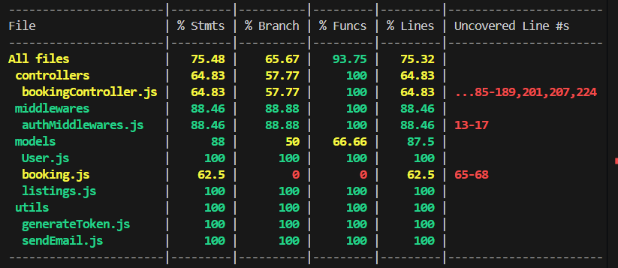

3. Coverage Report Submission
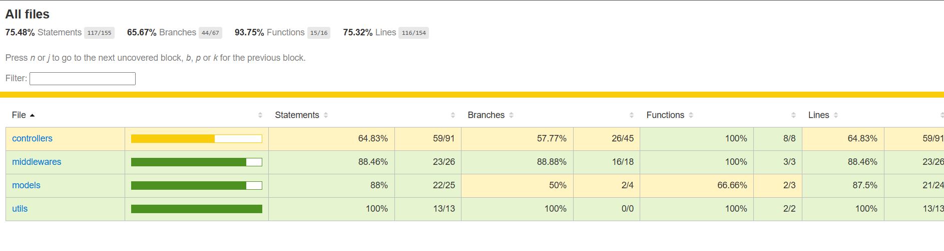

4. Coverage Explanation Note
The current test coverage report provides the following insights:
Overall Coverage:
- Statements: 75.48% of all statements are covered.
- Branches: 65.67% of all conditional branches are covered.
- Functions: 93.75% of all functions are covered.
- Lines: 75.32% of all lines are covered.
What is Covered Well
Controllers:
- Functions: All functions in the controllers folder are covered (100%).
- Statements and Lines: 64.83% of statements and lines are covered, which is decent but can be improved.
Middlewares:
- Statements, Branches, Functions, and Lines: The authMiddlewares.js file has excellent coverage (88.46%+ across all metrics). This indicates that most authentication and authorization logic is well-tested.

Models:
- User.js:
  - Fully covered (100% across all metrics). All schema fields, methods, and pre-save hooks are tested.
- Listings.js:
  - Fully covered (100% across all metrics). All schema fields and logic are tested.
Utils:
- generateToken.js and sendEmail.js:
  - Fully covered (100% across all metrics). All utility functions are tested, including edge cases and error handling.

What is Not Covered and Why
- controllers/bookingController.js:
  - Coverage: 64.83% (Statements and Lines), 57.77% (Branches).
  - Uncovered Lines: ...85-189,201,207,224.
Reasons:
  - Error Handling: Some error scenarios (e.g., database failures, invalid inputs) are not fully tested.
  - Edge Cases: Certain edge cases, such as unauthorized access or invalid status updates, are not covered.
  - Complex Logic: Functions like createBooking, updateBookingStatus, and deleteBooking have complex logic with multiple branches that are not fully tested.

- models/booking.js:
  - Coverage: 62.5% (Statements and Lines), 0% (Branches), 0% (Functions).
  - Uncovered Lines: 65-68.
Reasons:
- Pre-Save Hook: The pre("save") middleware for generating a unique confirmation code is not tested.
- Custom Logic: Any custom methods or schema validations are not covered.

- middlewares/authMiddlewares.js:
  - Coverage: 88.46% (Statements and Lines), 88.88% (Branches).
  - Uncovered Lines: 13-17.
Reasons:
- Edge Cases: Some edge cases, such as missing or malformed tokens, may not be fully tested.

Third-Party Libraries:
- Reason: Third-party libraries like jsonwebtoken, bcryptjs, and nodemailer are mocked in tests and not directly tested. This is standard practice to isolate application logic from external dependencies.
Unreachable Code:
- Reason: Certain branches or error scenarios may be unreachable during normal execution, such as unexpected database errors or invalid enum values.
Recommendations for Improvement
- controllers/bookingController.js:
  - Add tests for uncovered lines and branches:
  - Test error handling for database failures (e.g., Booking.findById or Listing.findById throwing errors).
  - Test edge cases for functions like createBooking (e.g., missing required fields, unauthorized access).
  - Test all possible branches in updateBookingStatus (e.g., invalid status values, unauthorized users).
- models/booking.js:
  - Add tests for the pre("save") middleware to ensure the confirmation code is generated correctly.
  - Test any custom methods or schema validations.
- middlewares/authMiddlewares.js:
  - Add tests for edge cases, such as:
  - Missing Authorization header.
  - Malformed or expired tokens.
Running Software Screenshots:

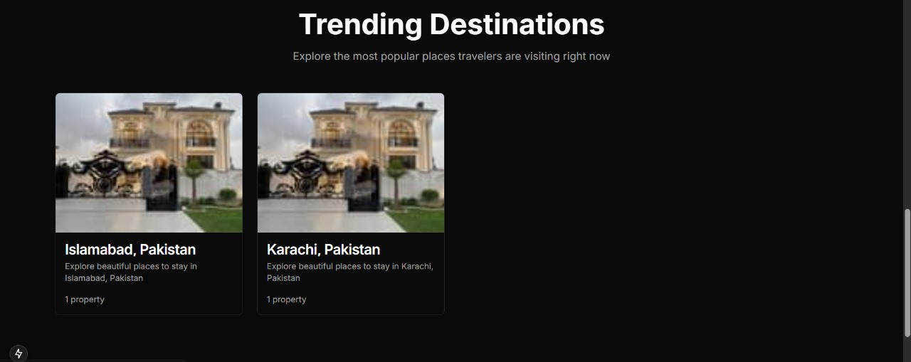
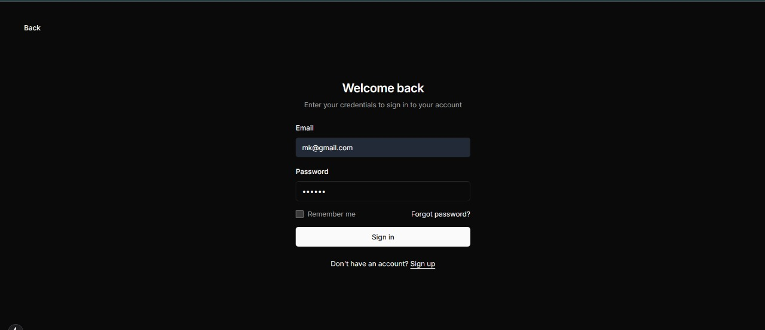
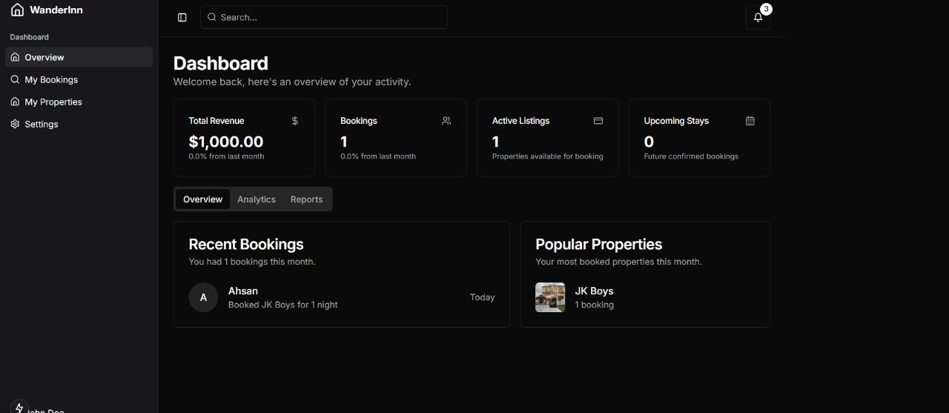
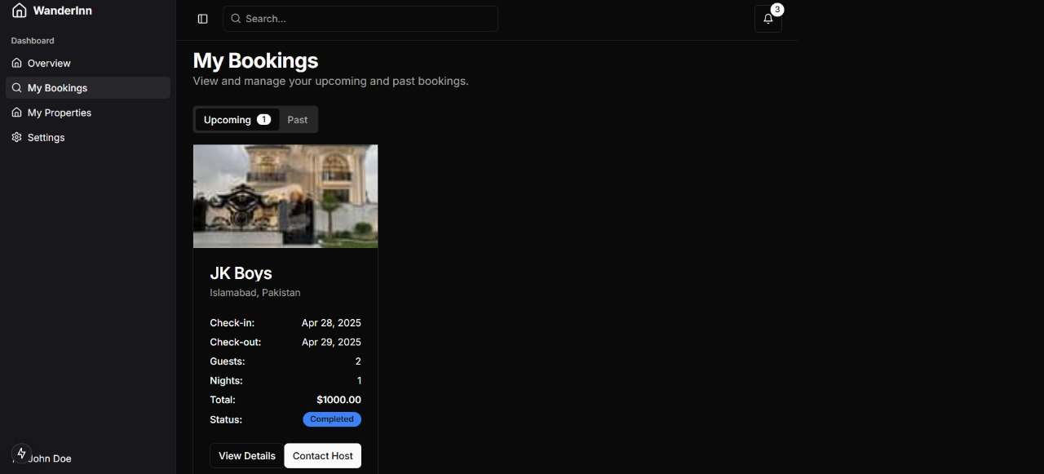
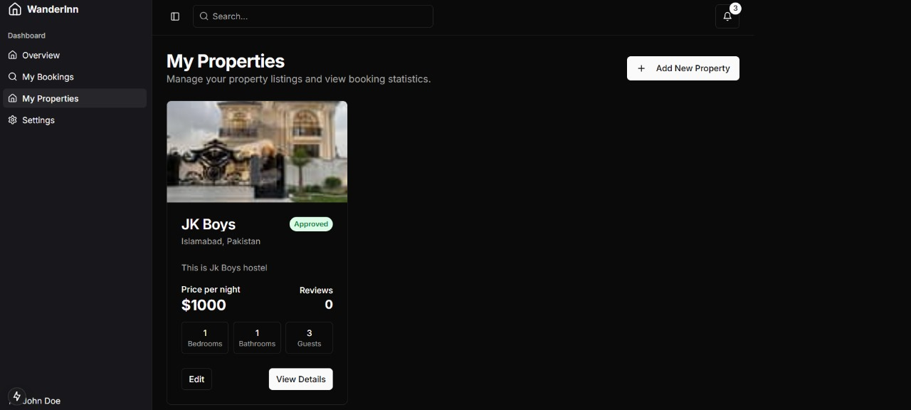
Product Burndown Chart:
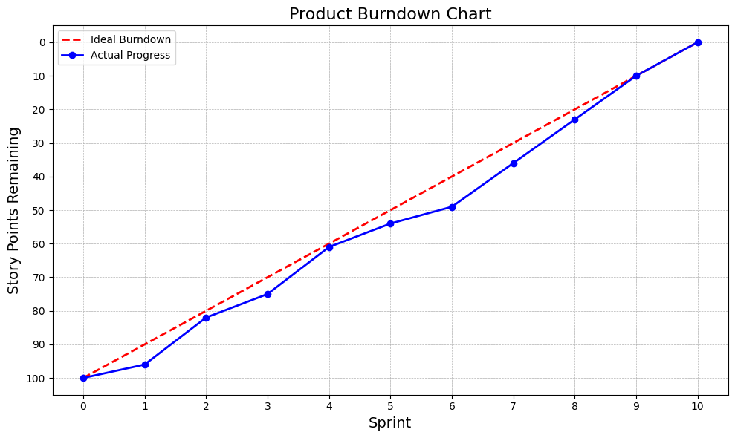

Group Work Division:
The work of the project was evenly distributed among the group members according to their interests and area of expertise
Front-end development was the responsibility of Maaz Khan.
- Back-end Development was a combined effort of M Rafay and Arham Khalid.
- Documentation was done by M Rafay and Arham Khalid.
Trello Board:

Start of project:
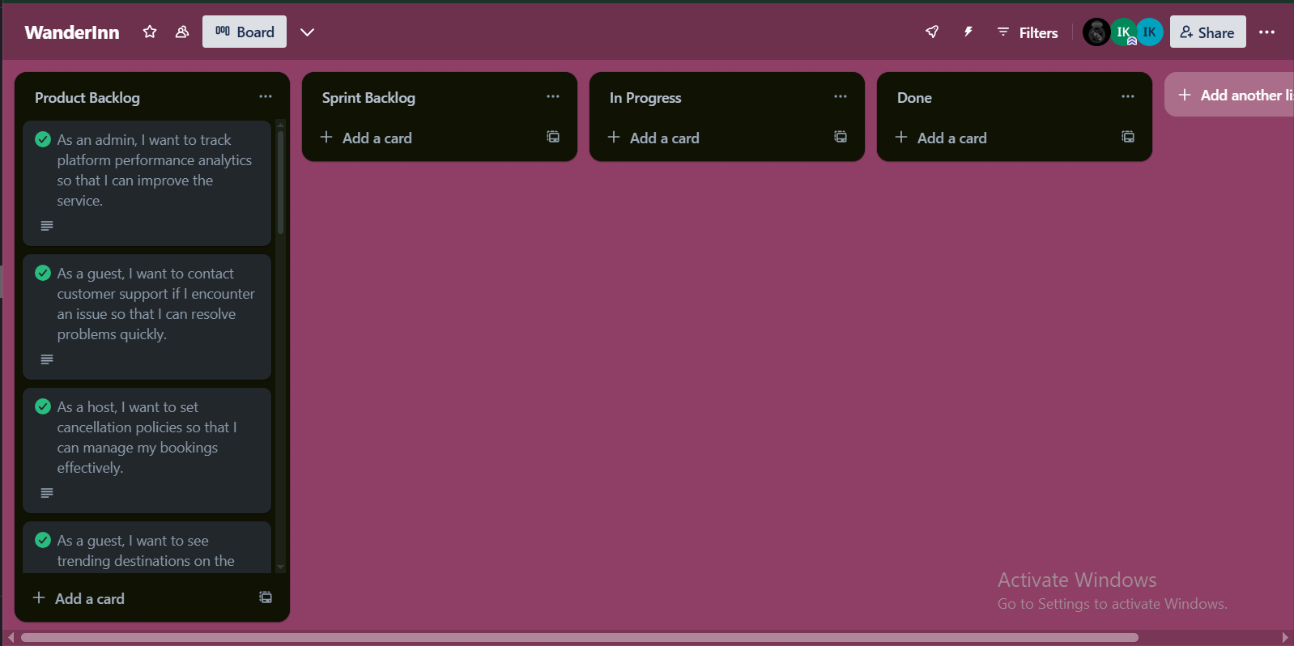

Project in progress:
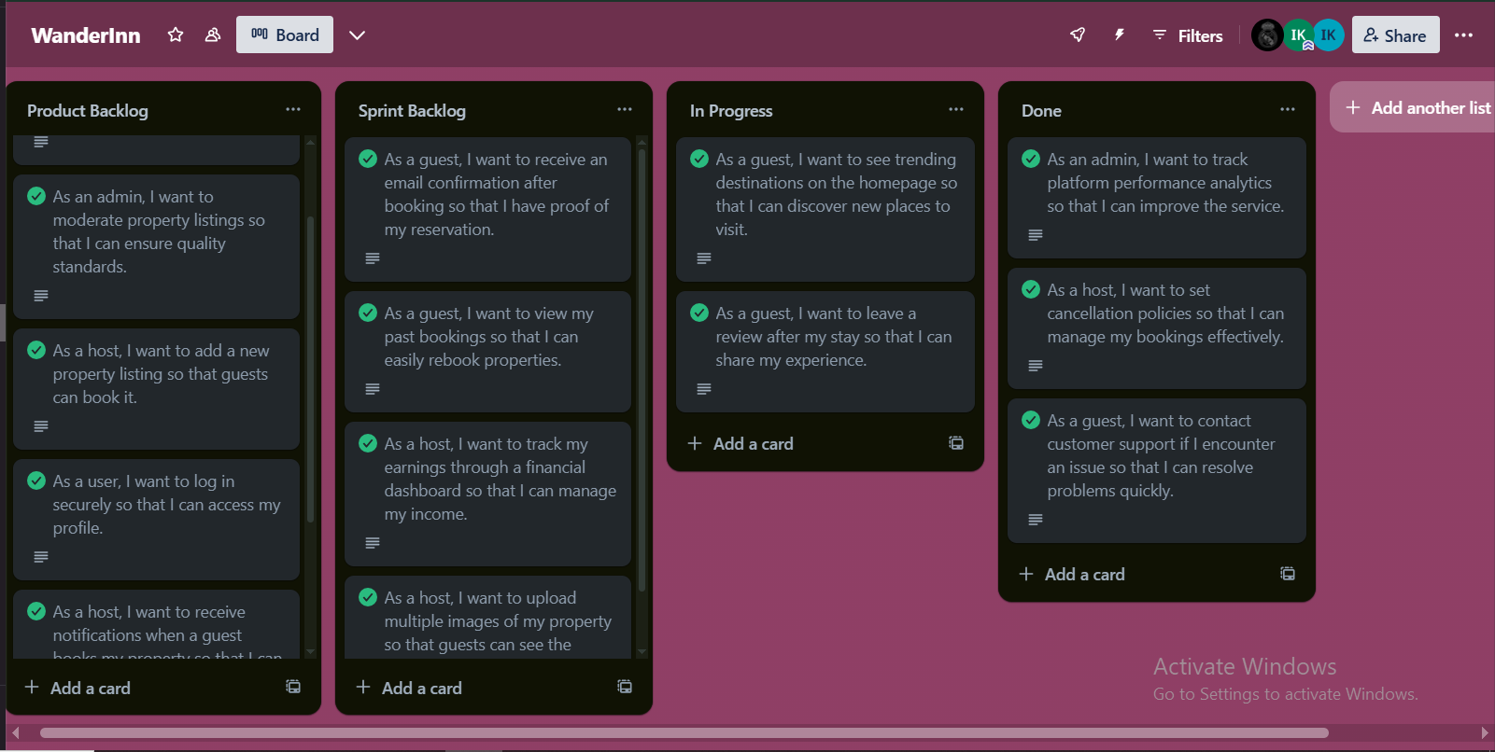

Project Completions:
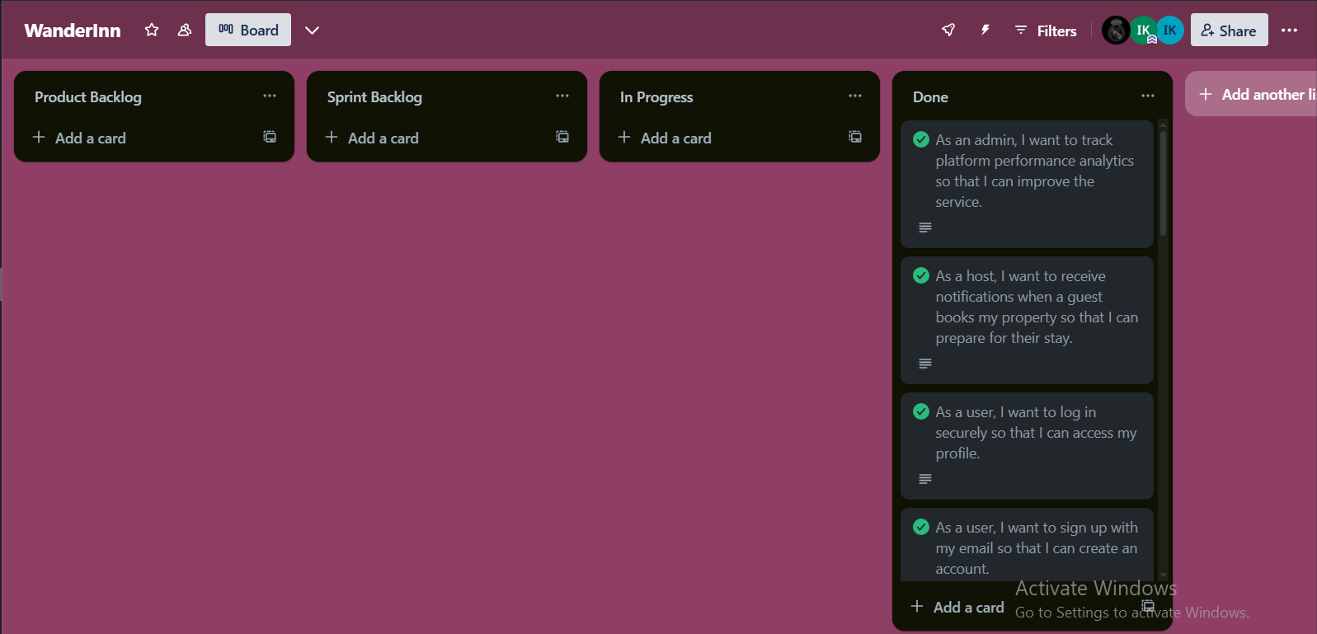

Lessons Learned by Group:
- Importance of Early Planning
We realized that investing time at the beginning to plan tasks, estimate story points accurately, and define clear sprint goals made the rest of the project flow much smoother. In the early sprints, lack of detailed planning led to some last-minute rushes.
- Clear Communication Reduces Rework
Regular stand-ups and frequent check-ins helped us catch misunderstandings early. Whenever communication broke down, it resulted in duplicated work or missed requirements, reinforcing how vital clarity is in a collaborative environment.
- Burndown Charts are More Than Just a Graph
Initially, we treated the burndown chart as a simple reporting tool. Over time, we learned it's a real-time indicator of team health, lagging progress highlighted hidden blockers or unrealistic estimates that we could address sooner.

